Chords – GCEA (Standard) Tuning

Maj/Minor

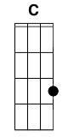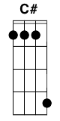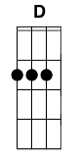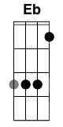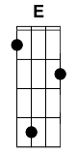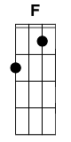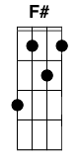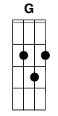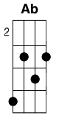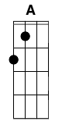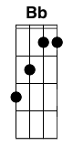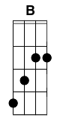

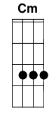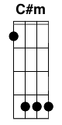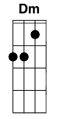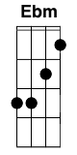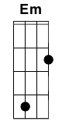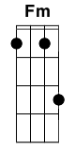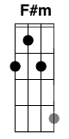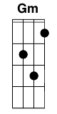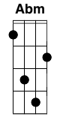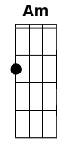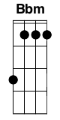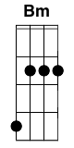

7

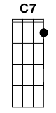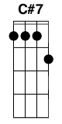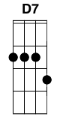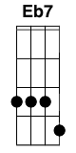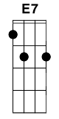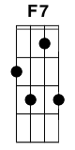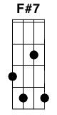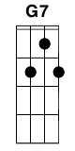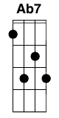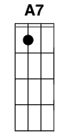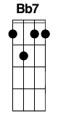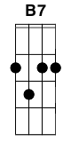

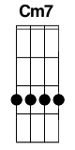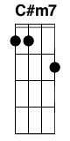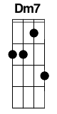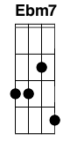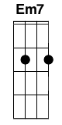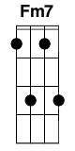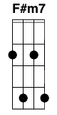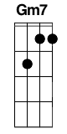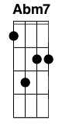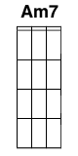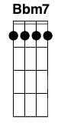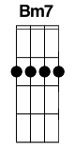

Maj

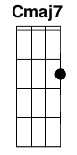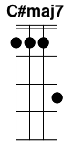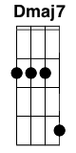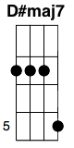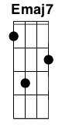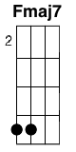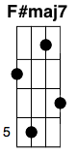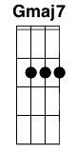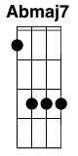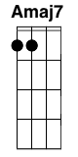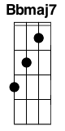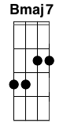

Sus

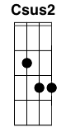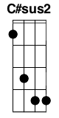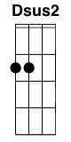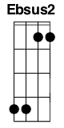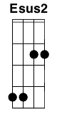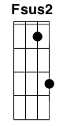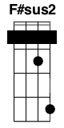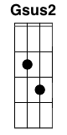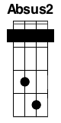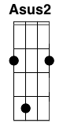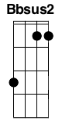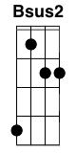

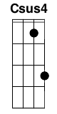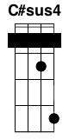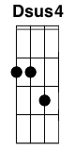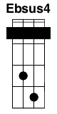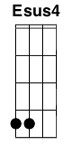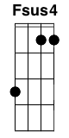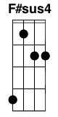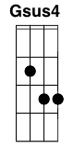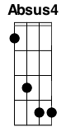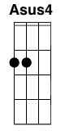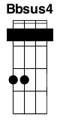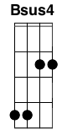

9

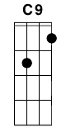 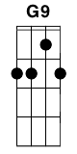 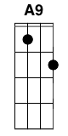

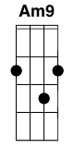

5

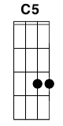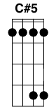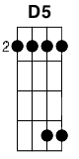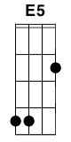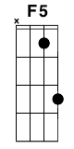 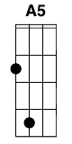 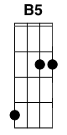

6

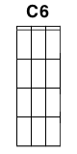 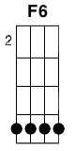 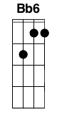

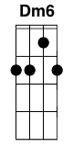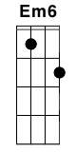 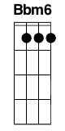

Misc

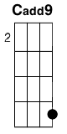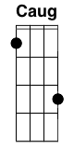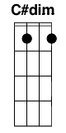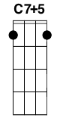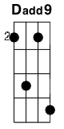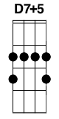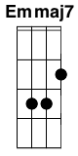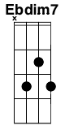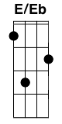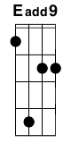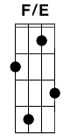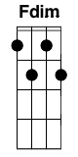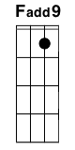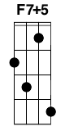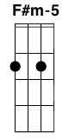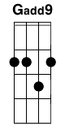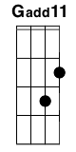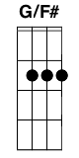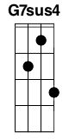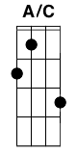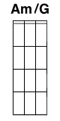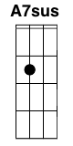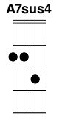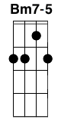

Variations

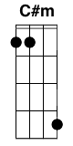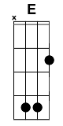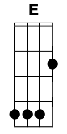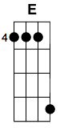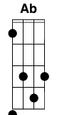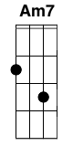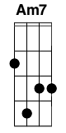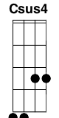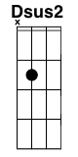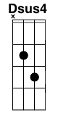

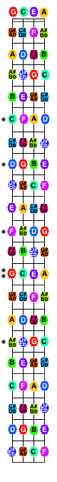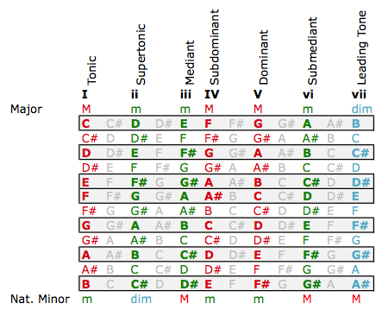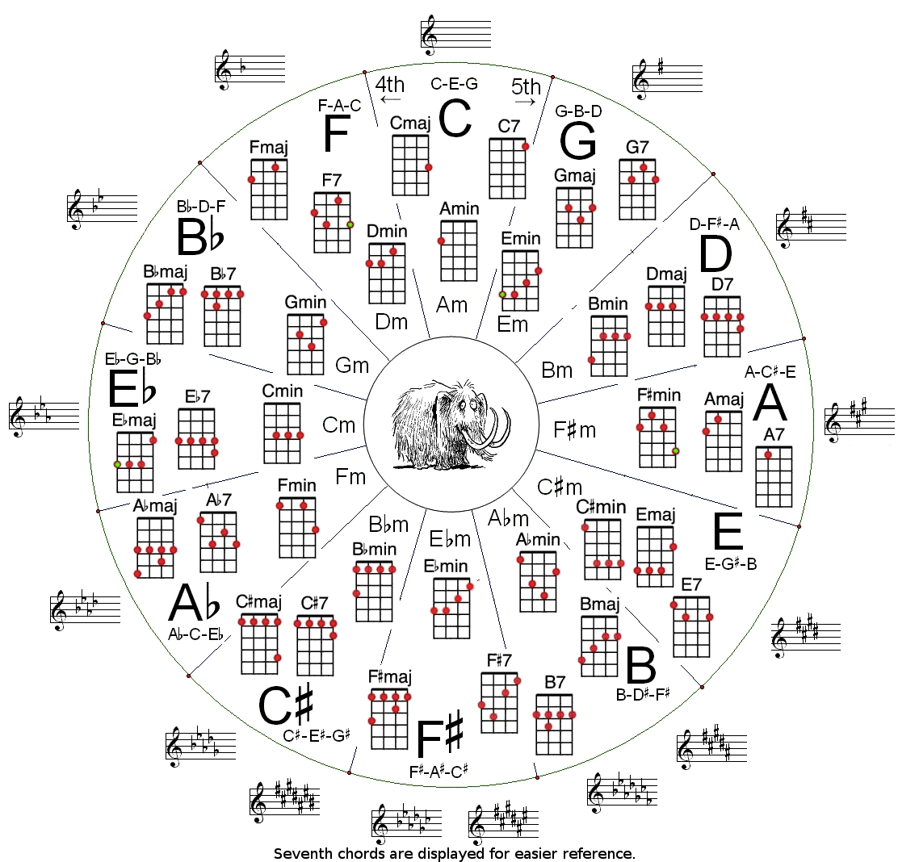

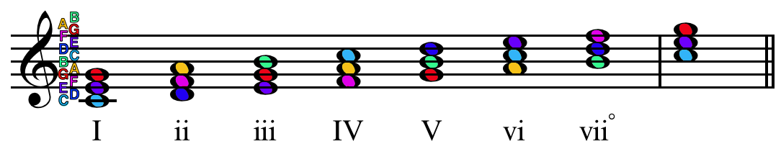

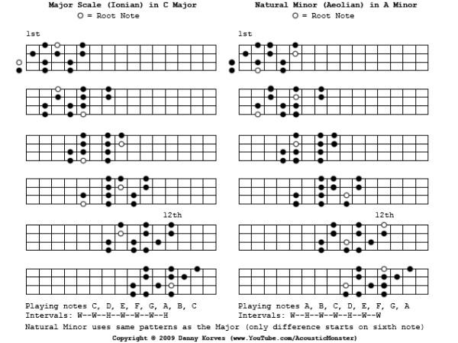

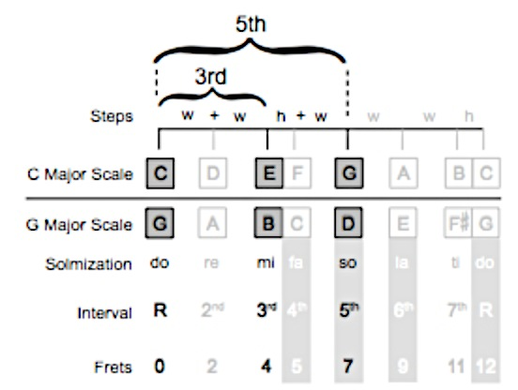

|  |  |
| --- | --- |
| **Chord** | **Leads To** |
| I | Can appear anywhere and lead anywhere |
| ii | I, V, or vii° chords |
| iii | I, IV, or vi chords |
| IV | I, ii, V, or vii° chords |
| V | I, vi chords |
| vi | I, ii, iii, IV, or V chords |
| vii° | I chord |

|  |  |  |  |
| --- | --- | --- | --- |
| Family | Name | Symbol | Formula |
| Major | Major | M, Maj | 1-3-5 |
|  | Added Fourth | add4 | 1-3-4-5 |
|  | Major 7th | Maj7 | 1-3-5-7 |
| Minor | Minor | m | 1-b3-5 |
|  | Minor added fourth | madd4 | 1-b3-4-5 |
|  | Minor sixth | m6 | 1-b3-5-6 |
|  | Minor seventh | m7 | 1-b3-5-b7 |
|  | Minor added ninth | madd9 | 1-b3-5-9 |
|  | Minor/Major seventh | m/Maj7 | 1-b3-5-7 |
|  | Minor seven flat fifth | m7-5 or ø | 1-b3-b5-b7 |
| Dominant | Seventh | 7 | 1-3-5-b7 |
|  | Seven sharp five | 7#5 | 1-3-#5-b7 |
|  | Seven flat five | 7b5 | 1-3-b5-b7 |
| Diminished | Diminished | dim (° ) | 1-b3-b5 |
|  | Diminished Seventh | dim7 (°7) | 1-b3-b5-bb7 |
| Augmented | Augmented | aug (+) | 1-3-#5 |
| Misc | Fifth | 5 | 1-5 |
|  | Flat Fifth | -5 | 1-b5 |
|  | Suspended Fourth | sus4 | 1-4-5 |
|  | Suspended Second | sus2 | 1-2(9)-5 |
|  | Sharp Eleven | #11 | 1-5-#11 |

*Note: Ninth, Eleventh, and Thirteenth chords cannot be played on ukulele.*

**Common 4/4 Strumming Patterns**

D-D-D-D- D-DU-UD-

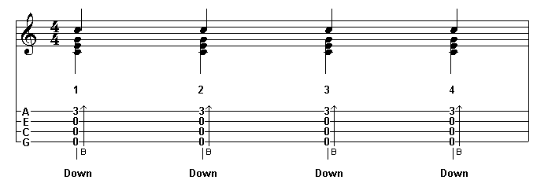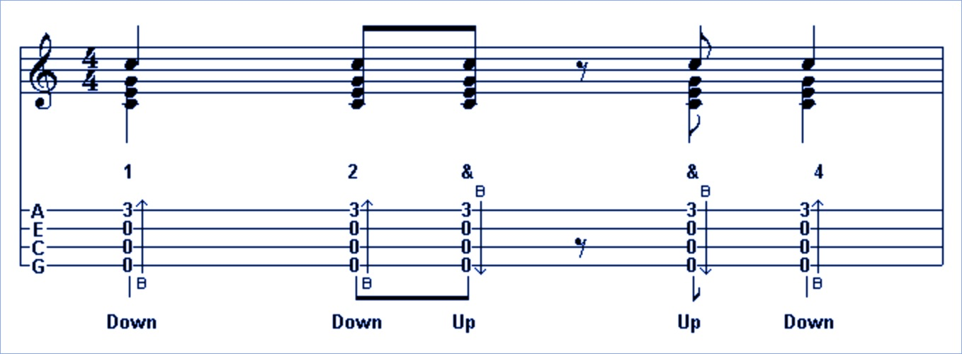

DUDUDUDU D-DU-UDU

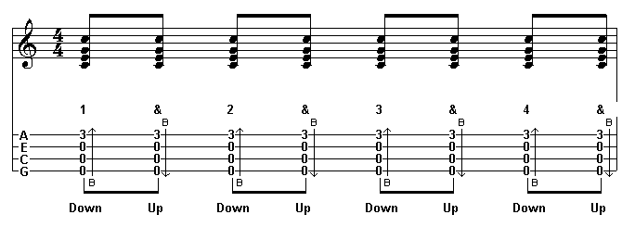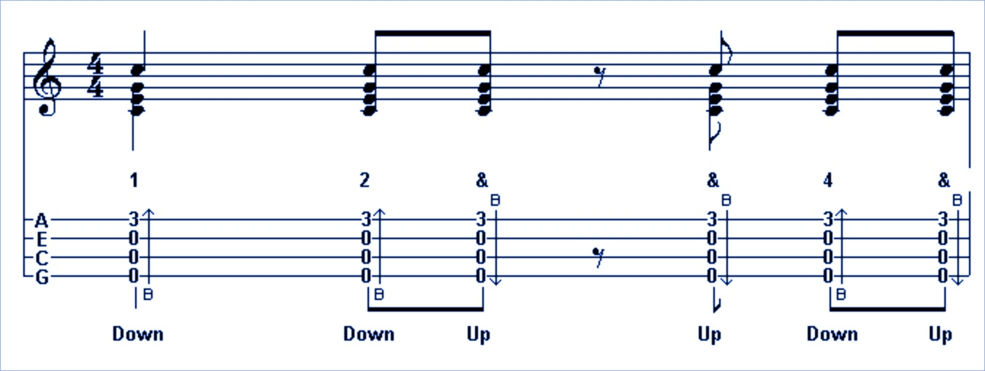

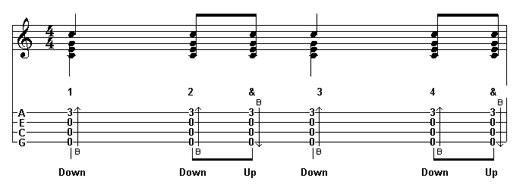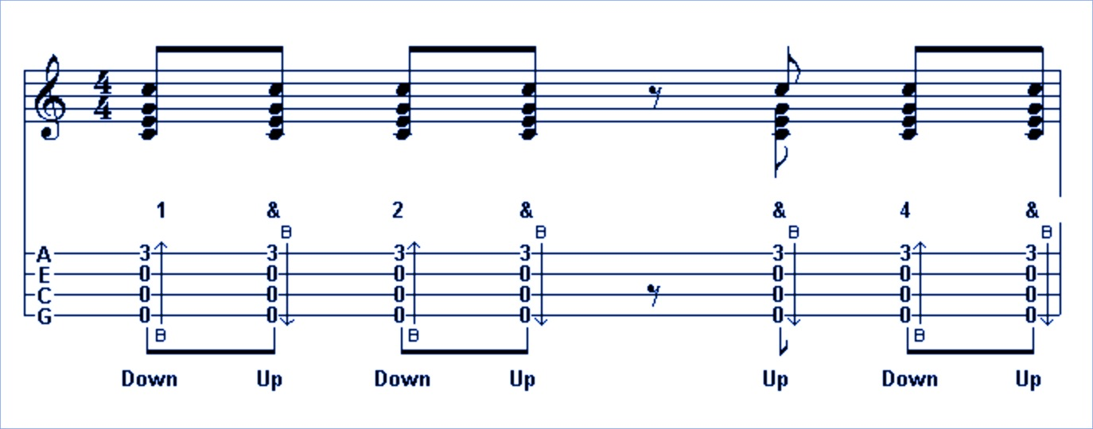D-DUD-DU DUDU-UDU

D-DUDUDU DUxUDUxU

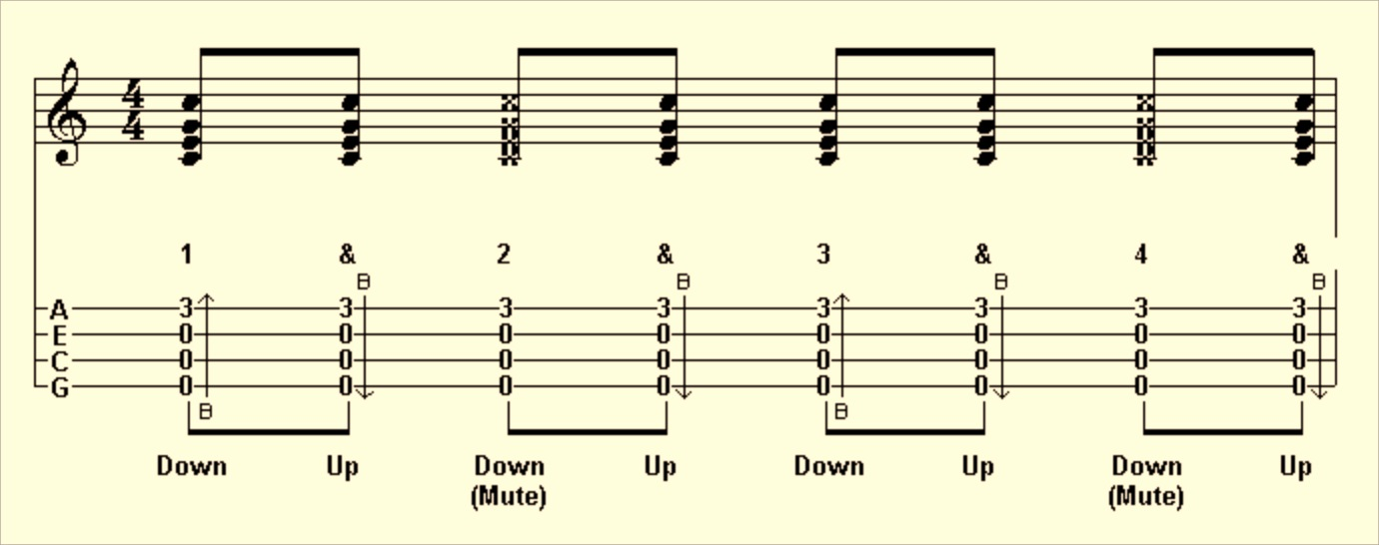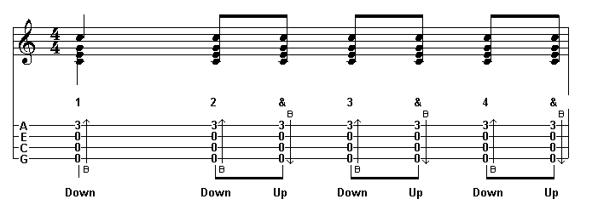

D-D-D-DU DUxUxUxU

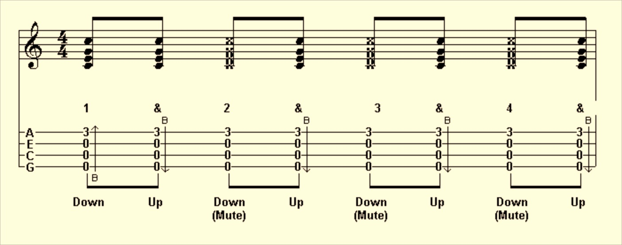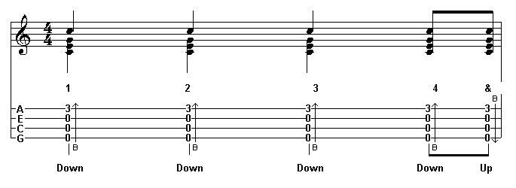

DUDUDUD- D-xU-UxU

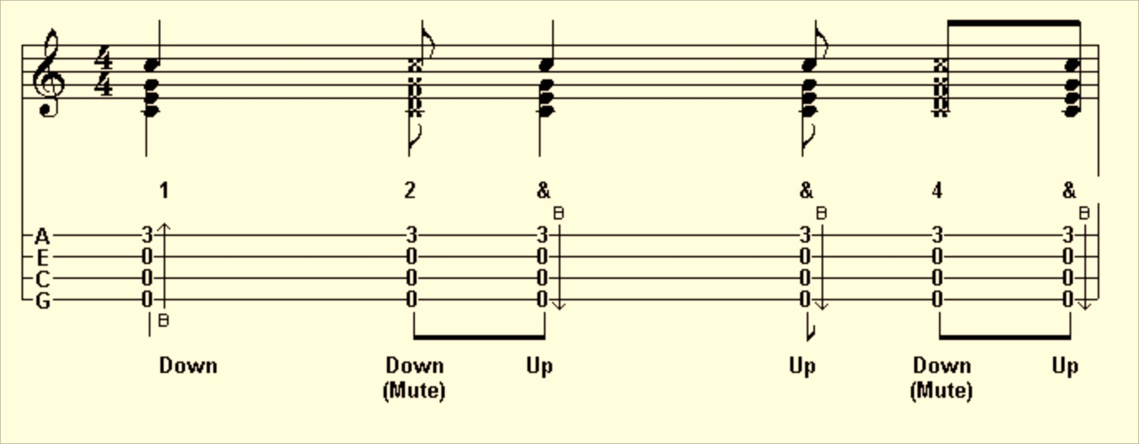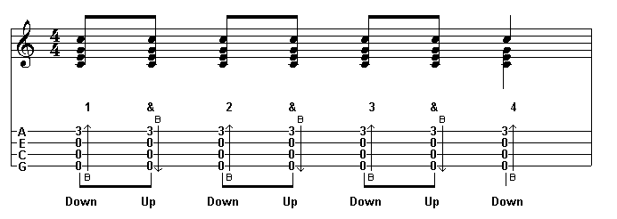

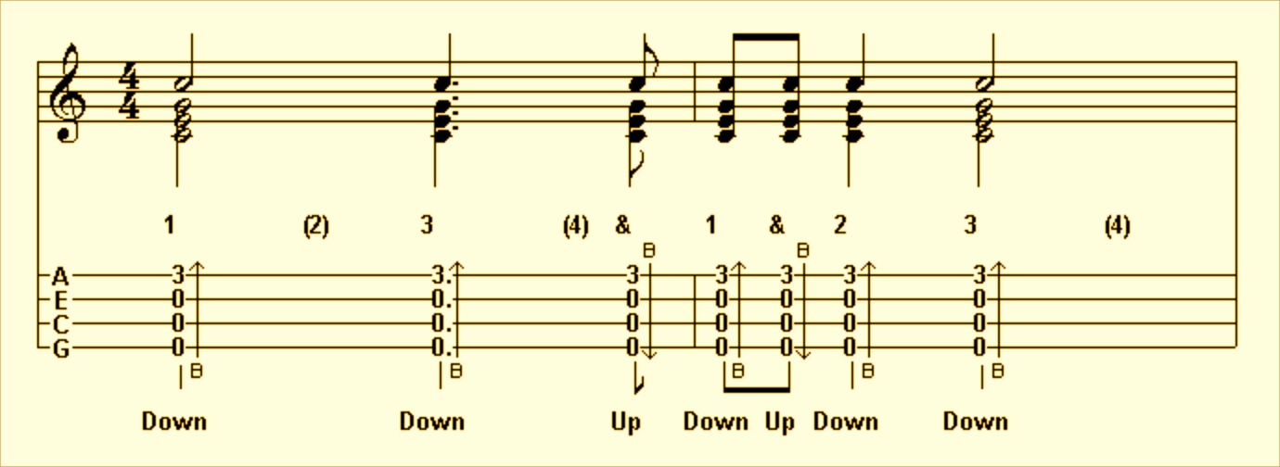D---D--UDUD-

S. Madeline: D-DU-UDU-UDU-UD-

Half-bar: DUxU

D-DU

Emphasis: duDUduDU

DUxUDUxU

Reggae: -D-D-D-D

3/4: D-DUD-

D-DUDU